**TI-30XS** Calculator Guide

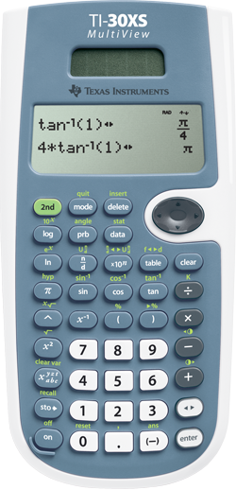

Parentheses for grouping

2nd + ( will give you %

2nd + ) will convert the number to a %

Clear the screen

ENTER/SOLVE

Negative Button

Fraction ⇔ Decimal

Operation Keys

2nd button used to convert Fraction ⇔ Decimal

Navigation Arrows

Exponent Key

n/d ⇒ fraction

2nd + n/d ⇒ mixed number

2nd + x10n ⇒ convert between

fraction and mixed number

2nd button used for anything in GREEN

2nd button used for square root

ON button

2nd + ON will turn your calculator OFF

**TI-84 Plus** Calculator Guide

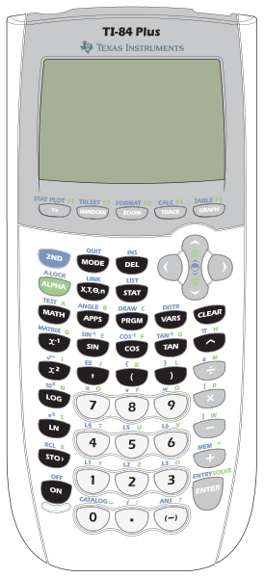

Clear the screen

Exponent Key

Operation Keys

Navigation Arrows

Negative Button

ENTER/SOLVE

ON button

2nd + ON will turn your calculator OFF

Parentheses for grouping

MATH menu gives options to convert between Fractions, Decimals, and other operations.

Alpha + y=

Shows fraction buttons

2nd Button used for anything in BLUE

ALPHA Button used for anything in GREEN